AP Physics Summer Assignment
The AP Physics summer assignment is designed to familiarize you with the learning and assessment platform we use extensively in class. It is important that you complete the assignment to ensure you enrolled in the platform and know how to input answer types.
STEP 1
Creating a Username & Password
Returning Physics Students: You will use your same username and password. Simply enroll in the new course using the unique ID number provided.

New AP Physics Students: You will need to make a Quest username and password then enroll in the course to view the assignments.
Making a username and password.
- Google Quest Texas
- Click the main link
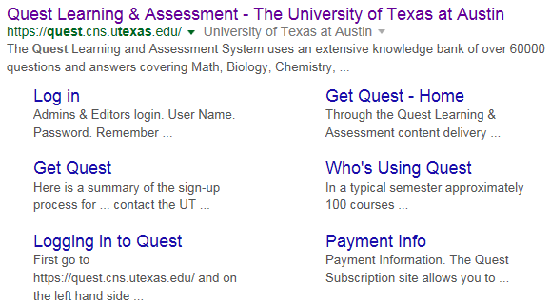

- Click “Log into Quest” in the upper right of the page
- Click the “I need a UT EID in the middle of the page
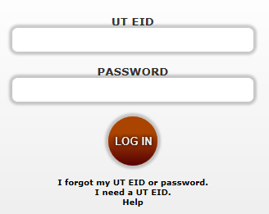
- Follow the directions to create a username and password.

***Write down your username and password. If they are lost you can only get them back by contacting the Quest site admin. There is nothing I can do to help.
AP Physics Quest Guide
STEP 2
Enrolling in a Course

Before enrolling in a course you will have had to create a username and password. See step 1 instructions for additional information.
To enroll in your course:
- Google “Quest Texas” and select the main link
- Click “Enroll in a new Course” in the upper left corner of the page
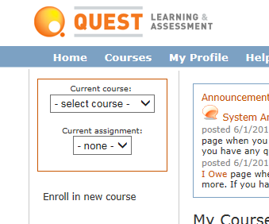
- Type in the unique course ID for the Physics class in which you are enrolled.
  - AP Physics 1 (Algebra): 201700
  - AP Physics C Mechanics (Calculus): 201711
  - AP Physics C Electricity & Magnetism (Way more calculus): 201722
- Your enrollment will have to be approved before you can access the course.
- Read over the Quest resources and information provided in the course link once you have access. Answers to questions should not be rounded at all and at least 6 numeric digits should be entered.
***Important note: I do not check the new Quest enrollments with any regularity over the summer. You need to be enrolled and accepted into the course before the end of this school year. Procrastination over the summer is not only an unacceptable excuse but it will not constitute and emergency on my part. Avoid this pitfall and enroll early.

